Math 1050 Mortgage Project
Home purchase price= $201,000
Down payment= %10 201,000 x 0.1= 20100 Down payment= $20,100
Mortgage amount= 201000-20100=108900 Mortgage amount= $108,900

Part I: 30 year Mortgage
$$PMT=\frac{P (\frac{r}{12})}{1-{\left(1+\frac{r}{12}\right)}^{-12Y}}$$
P =108900 r =0.04975 Y= 30 years
$$PMT=\frac{108900(\frac{0.04975}{12})}{1-{\left(1+\frac{0.04975}{12}\right)}^{-12\left(30\right)}}$$
$$PMT= \frac{451.48125}{1-{\left(1.004145833\right)}^{-360}}$$
$$PMT= \frac{451.48125}{0.774495367}=582.9360242$$
Monthly Payment for a 30 Year mortgage= $582.94
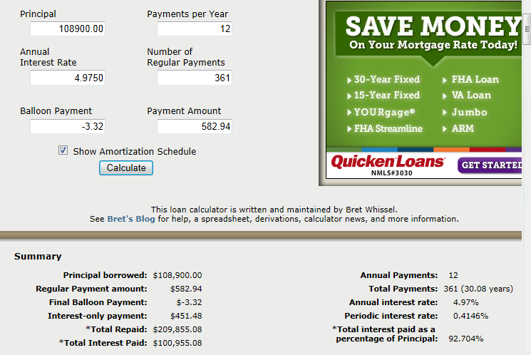
Amortization Schedule:

Amortization Schedule monthly payment for a 30 year mortgage= $582.94
Total interest paid over 30 years= $100,955.08
Total amount paid= $209,855.08
As time passes, the amount paid towards the principle increases while the amount paid for interest decreases. BUT in the beginning, you are practically paying all interest.
Number of first payment when more of payment goes toward principal than interest= 278th
$$\frac{monthly principle+interest payment}{monthly takehome pay}=\frac{35}{100}$$
$$\frac{582.94}{x}=\frac{35}{100}$$
$$\frac{582.94×100}{35}=1665.542857$$
Minimum monthly take home pay (net pay) = $$1,665.54$
$$\frac{net pay}{gross pay}=\frac{73}{100}$$
$$\frac{1665.542857}{x}=\frac{73}{100}$$
$$\frac{1665.542857×100}{73}=2281.565558=Monthly gross salary$$
$$2281.565558×12=27378.7867=gross annual salary$$
Minimum gross annual salary= $27,378.79

Part II: Selling the House
$$A=Pe^{rt}$$
$$A=201000e^{.04\left(10\right)}$$
$$A=299856.7642$$
Value of home 10 years after purchase= $299,856.76
Selling price of your house= $201,000
Original down payment= $20,100
$$Cumulitive principle+Cumulitive interest=Cumulitive Mortgage paid$$
$$20385.94+49566.86=69952.8$$
Mortgage paid over the 10 years= $69,952.80
Principle balance after 10 years of payments= $88,514.06
$$Original down payment+mortgage paid=amount paid over 10 years$$
$$20100+69952.80=90052.8$$
$$Amount I sold home for-amount paid over 10 years=money gained or lost$$
$$299856.7642-90052.8=209803.96$$
I gained $209,803.96 over the 10 years. Summarization of results (see above).

Part III: 15 year Mortgage:
$$PMT=\frac{108900(\frac{0.04735}{12})}{1-{\left(1+\frac{0.04735}{12}\right)}^{-12\left(15\right)}}$$
$$PMT=\frac{429.70125}{1-{\left(1.003945833\right)}^{-180}}$$
$$PMT=\frac{429.70125}{.507791243}=846.2163456$$
Monthly payment for a 15 year mortgage= $846.22

Amortization schedule:
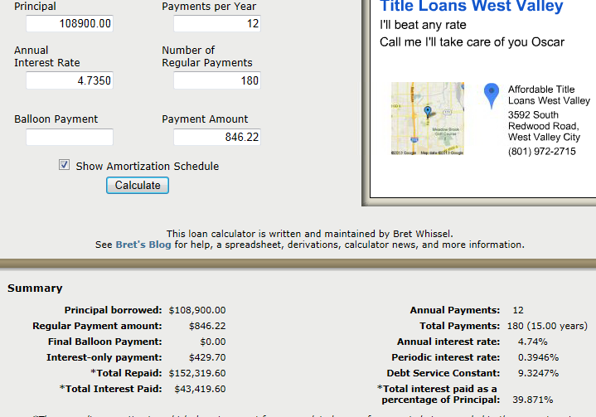

Amortization Schedule monthly payment for a 30 year mortgage= $846.22
Total interest paid over 30 years= $43,419.60
Total amount paid= $152,319.60
Number of first payment when more of payment goes toward principal than interest= 5th
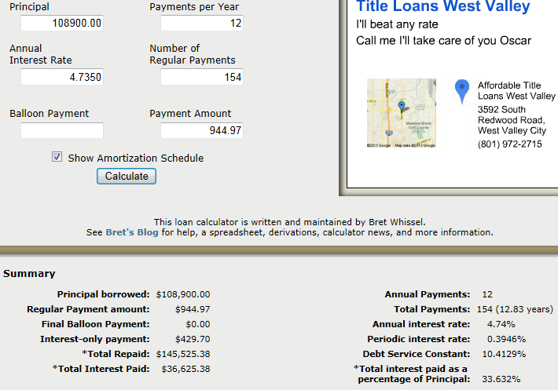
Amortization schedule with additional payments of $100 per month:

Length of time to pay off loan with additional payments of $100 per month= 12.83 years
Total interest paid over the life of the loan with additional $100 monthly payments= $36,625.38
Total amount paid with additional $100 monthly payments= $145,525.38
$$Total amount paid for 15 year mortgage-Total amount paid for 15 year mortgage with \$100 additional monthly payment=Amount gained of lost$$
$$152,319.60 - 145,525.38= 6794.22$$
I would spend $6,794.22 less just by paying the additional $100 monthly payment.

Part III: Reflection
I thought buying a home cost a lot. I thought if I were to buy a house I would have to pay 1,000 or more just on the monthly payment. In this project we did the calculations according to the interest rate, amount paid and time. I knew that the interest rate decreases while the amount paid towards the payment increases, but I didn’t realize how the monthly payment can decrease according to the amount of time the loan is set for and the amount of extra money that can be put towards the principle if desired.
Right now I am paying $650 for a basement I don’t even like because it is the cheapest we were able to get. Furthermore the money we pay for rent is being given to someone else, it is not being put towards any purpose/benefit to us and we will never see that money again. It is interesting to me to see that on a 30 year contract, for a house that cost $201,000 and a down payment of $20,100 we can pay $582.94, less than what we are paying right now. This also comes with benefits like: ITS A HOUSE, we have our own backyard, we don’t hear people above or below us, its more private and we can do what we want with it practically. Furthermore we could sell it later and gain at least our money back (that’s better than paying thousands of dollars to a landlord where we’ll never see that money again.).

